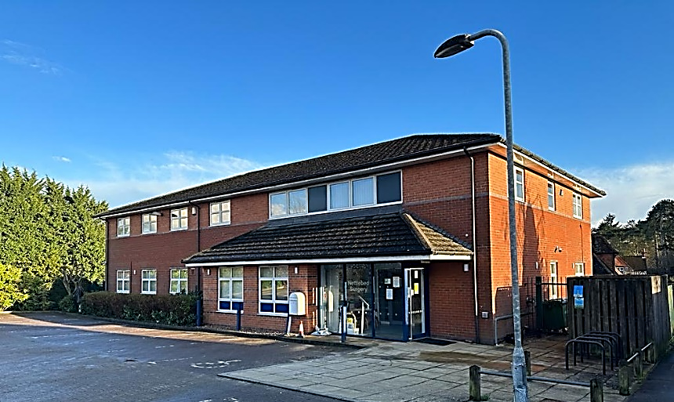

Nettlebed Surgery Newsletter

Health Notices This Month
Anthony Morris, The Chair
Dilys Wilde, The Secretary

Members:
Annabel Bosher
Gillian Ovey,
Wendy Ayre-Tilbury and
William Murdoch.

YOUR PPG COMMITTEE MEMBERS

Practice & Patients in Partnership
Issue No: 03 (September 2026)

Welcome
Welcome to the latest edition of the Nettlebed Surgery Newsletter. There has been a great deal happening at the practice in recent months, and we are pleased to share an update with you — including some new faces you will want to meet.

A Message from the Partners

After an extraordinary 34 years of service to Nettlebed Surgery and our local community, Dr Lisa Silver has decided to step back from her role at the practice. Lisa has been a much-loved and highly respected GP, caring for generations of patients and making an enormous contribution to the life of the surgery. Her dedication, warmth, and commitment to Nettlebed will be greatly missed by patients and colleagues alike. We look forward to celebrating Lisa’s remarkable contribution with the community in October and wish her every happiness in this next chapter.

We have welcomed several new colleagues across our clinical, management, and dispensary teams, and we are delighted to introduce them over the next few pages - please do give them a warm Nettlebed welcome when you see them.
Thank you, as always, for your patience, your feedback, and your continued support of the surgery and our whole team.

Dr Ravpreet Kaur & Dr Harmandeep Singh, Partners

As we head into the colder months, we would encourage everyone who is eligible to make sure their flu and COVID-19 vaccinations are up to date. Vaccination remains an important way to reduce the risk of becoming seriously unwell over winter, particularly for older people and those with long-term health conditions. If you are eligible, you can book your vaccination by calling Nettlebed Surgery or booking online. Please do not wait until winter is fully underway - book early and help protect yourself and those around you.

Norovirus: Cases locally are running about 24% above the usual level. Please stay away from the surgery, work, or school until 48 hours after symptoms fully stop and wash hands with soap - gel does not kill it.

Hay Fever: Grass and weed pollen remain high through August. Vaseline around the nostrils and a shower after being outdoors can help; ask your pharmacist about antihistamines.

For non-urgent advice, call NHS 111. In a medical emergency, always call 999.

New Faces at Nettlebed

Dr Harmandeep Singh - Non-Clinical Partner
Dr Simran Karir - Salaried GP
Rita Cabrita - Practice Manager
Tracey Kelly - Diabetes Specialist Nurse
Debbie Cooper – Practice Nurse
Kelly Lins e Silva - Dispenser
Helen Morgan – Dispenser
Jacqui Croker- James – Patient Services

A New Chapter in Practice Leadership

Dr Harmandeep Singh - Non-Clinical Partner
We are pleased to share that Dr Harmandeep Singh is Non-Clinical Partner at Nettlebed Surgery, working alongside Dr Ravpreet Kaur in the leadership of the practice. Dr Singh will continue to work in his regular job as a Cardiologist in West London and will be at surgery on Friday’s.

As Non-Clinical Partner, Dr Singh’s focus’ is on the strategic, organisational, and business side of running the surgery, rather than providing GP consultations - supporting Dr Kaur’s clinical leadership so that our clinical teams can concentrate on patient care.

For patients, our priority remains the same: safe, compassionate, and accessible healthcare from a team that knows and cares about this community.

Rita Cabrita - Practice Manager
Rita leads the day-to-day management of the surgery, supporting our clinical and administrative teams and helping make sure our services run safely and smoothly. If you have a query about how the practice operates, Rita and her team are usually your first point of contact.

Meet Our New Team

We are delighted to welcome several new colleagues to Nettlebed Surgery this year. Please join us in giving them a warm welcome when you see them around the practice.

Dr Simran Karir - Salaried GP
Dr Karir joined the practice on 6 August 2026 and works alongside Dr Ravpreet Kaur, and the rest of our clinical team, seeing patients across the full range of concerns usually managed in general practice. Her appointment adds valuable capacity to our GP rota and helps us offer greater continuity of care. Her working days are Thursdays and Fridays.

Tracey Kelly - Diabetes Specialist Nurse
Tracey runs our dedicated diabetes clinics, supporting patients with reviews, monitoring, and day-to-day management of their condition. If you are due a diabetes review, keep an eye out for your invitation — Tracey's clinic is where you are likely to be seen.

Kelly Lins e Silva & Helen Morgan- Dispensary Team
Our dispensary is an essential service for many of our patients, particularly in a rural area like ours. Kelly & Helen join as Dispensers, overseeing the safe day-to-day running of the dispensary, helping prepare and issue medication for our dispensing patients.

Debbie Cooper
Debbie joined the practice on 14th September 2026 and works alongside the rest of our clinical team, assessing and treating patients in a wide range of topics such as chronic disease management, treatment room services, acute assessments, and patient education.

Jacqui Croker- James
Jacqui joined the practice on 17th September and is part of the Patient Services team. Being front of the house, she is responsible for welcoming patients and helping them with their requests, either via face to face, telephone, or email.

Soon to join Nettlebed Surgery

Dr Upinder Sidhu

Dr Upinder Sidhu is a newly qualified general practitioner and will join Nettlebed Surgery in early October. Her working days are Mondays, Tuesdays and Wednesdays and she will complement Dr Kaur and Dr Karir in providing medical care, diagnosis and treatment and referrals to the patients of Nettlebed surgery.

Leavers

Nettlebed surgery has recently bid farewell to several staff who embarked on their next journey:
- Olga James
- Jenny Sayer
- Ann Saddler
- Charlotte Bradley
- Julie Maunder
- Mariola Krepa

More From Nettlebed Surgery

Thank You — GP Patient Survey
Thank you to everyone who took part in our GP Patient Survey. In the most recent published results (2025), 93% of patients rated their overall experience as good or very good, 91% were able to speak to a healthcare professional when they needed to, 97% felt listened to during their last appointment, and 95% trusted the healthcare professional they saw or spoke to.
Patient feedback helps us understand what is working well and where to improve. Behind these results is the work of our whole team — GPs, nurses, dispensary, Patient Services, and administrative colleagues alike — and we are grateful to them, and to every patient who took the time to share their views.

Getting the Right Help from the Right Person
General practice has changed a great deal, and seeing a GP is not always the quickest or most appropriate way to get help. Depending on what you need, our Patient Services team may arrange for you to see - or direct you to - a GP, Practice Nurse, Diabetes Specialist Nurse, Healthcare Assistant, Clinical Pharmacist, Social Prescriber, a community pharmacist, or NHS 111.
Our Patient Services team will usually ask a few questions when you contact us. This is not meant to make things harder - it helps them direct your request safely to the right person. We would be grateful for your patience in answering these.

Remember your local pharmacist can now treat seven common conditions — including sinusitis, sore throat, earache in children, infected insect bites, impetigo, shingles and uncomplicated UTIs in women aged 16 - 64 - without needing a GP appointment, through NHS Pharmacy First.

A Reminder About Prescriptions & Our Dispensary
Our dispensary team handles a high volume of prescriptions, so please allow enough time when ordering repeat medication — ideally avoid leaving it until you have completely run out. The NHS App is a convenient way for many patients to order repeat prescriptions.

When collecting medication, our team may ask you to confirm some identifying details. These checks are an important part of keeping patients and their medicines safe, and we appreciate your patience with them.

Your Patient Participation Group (PPG)
Our PPG provides an important link between patients and the practice, helping us consider patient views and identify opportunities to improve our services. You will find our current committee members on the front page.

We would love the group to represent the full range of people who use Nettlebed Surgery — younger patients and working-age adults, as well as parents, carers, and older members of our community. You do not need any medical knowledge to take part, just an interest in helping make local primary care the best it can be. If you are interested in joining, please contact reception and we will put you in touch with the Chair.

Please Cancel Appointments You Can't Attend
Every appointment is valuable. If you are unable to attend, please let us know as early as you can, even at short notice — it allows us to offer that slot to another patient who may be waiting. A quick call, or cancelling online where available, makes a real difference.

Keep Your Details Up to Date
Have you recently changed your address, home or mobile number, or email address? Please let us know. Accurate contact details help us reach you about appointments, referrals, screening, vaccinations, and other aspects of your care.
Please do not send confidential clinical information by email or other insecure means - contact the surgery through our usual channels if you need to discuss your healthcare.

We are Recruiting
We are currently recruiting a Practice Nurse (2 sessions per week). If you, or someone you know, might be interested, please see the vacancy details on our website or contact Rita Cabrita, Practice Manager.

A Thank You to Our Team
Periods of change can be challenging for any organisation, and general practice is no exception. We would like to thank our existing staff, who have continued supporting our patients while helping new colleagues settle in.
From answering the phone and managing appointments, to dispensing medicines, providing nursing care, and seeing patients in the consulting room — every member of the team helps keep Nettlebed Surgery running. To our established colleagues and our newest recruits alike: thank you for everything you do for our patients.

Support Nettlebed Surgery Medical Trust
The Nettlebed Surgery Medical Trust is our local charity, which helps fund additional equipment and services for patients beyond what the NHS routinely provides. If you would like to make a donation — by cheque, cash, or bank transfer — our reception team can give you the current details, or you will find them on our website.

And Finally… Thank You to Our Patients
Nettlebed Surgery has served this community for many years, and we are proud to remain part of it. Thank you for your patience, your constructive feedback, and the kindness you show our staff.
We look forward to the months ahead, and hope you will join us in welcoming Dr Simran Karir, Rita Cabrita, Tracey Kelly, Mariola Krepa, Kelly Lins e Silva and Dr Harmandeep Singh to the Nettlebed Surgery team. Welcome to Nettlebed Surgery!

Feedback, Complaints and Suggestions
We welcome your feedback, good or bad — it helps us improve. Please speak to a member of the reception team, or email us, if you have a comment, suggestion, or complaint. Full details of our complaint’s procedure are available on our website and at reception.

Nettlebed Surgery
Wanbourne Lane, Nettlebed, Henley-on-Thames, Oxfordshire RG9 5AJ
Tel: 01491 641204 • Email: reception.k84015@nhs.net • nettlebedsurgery.nhs.uk
Opening hours: Monday-Friday, 8:00am-6:30pm. NHS 111 for urgent (non-emergency) help. In a life-threatening emergency, always call 999.

